**Tree Recycling Option 1: Erosion Control**

Riverbanks in our county are eroding because of flooding. In southern states, Christmas trees are used to slow erosion. People put them on riverbanks. The city wants to copy this but is not sure which trees are best.

**The Challenge**: Design a riverbank barrier using Christmas trees to help prevent erosion.

**Constraints**:

* Uses 2 or more tree types
* Compares two design ideas
* Focuses on water erosion
* Uses supplies provided (ask your teacher)

**What has been done before**:

Cut trees are placed on sand beaches.

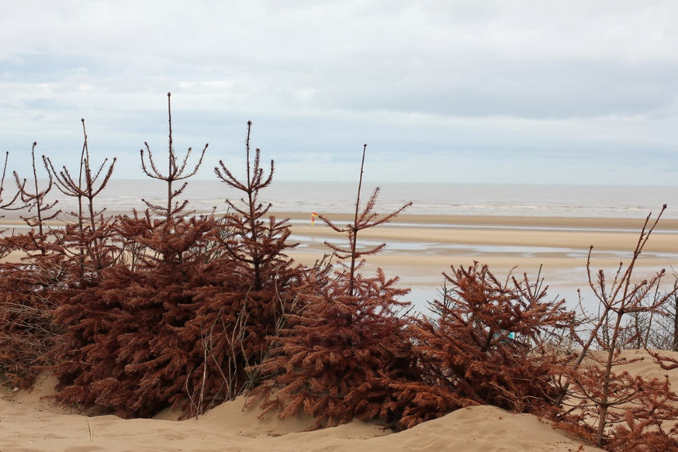

Cut trees are laid down on riverbanks.

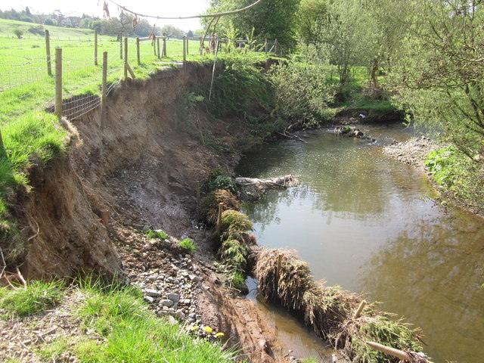

**Tree Recycling Option 2: Wood Chips**

Our town has many gardeners. Gardeners struggle to control weeds. One way to keeps weeds from growing is using wood chips. Old Christmas trees can be cut up to make wood chips. But the local greenhouse does not know which combinations would be best.

**The Challenge**: Design a wood chip combination that will slows weed growth **OR** wind erosion.

**Constraints**:

* Made from 3 types of wood chips
* Compares two design ideas
* Stops weeds from growing OR slows wind erosion
* Uses supplies provided (ask your teacher)

**What has been done before**:

Wood chips are placed on top of soil. They help to stop some plants from growing.

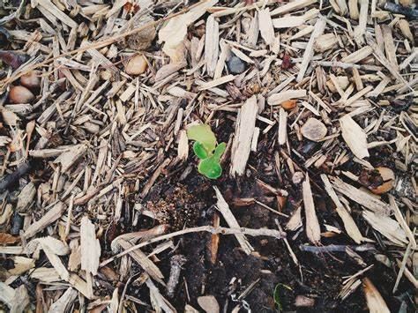

Christmas tree wood chips sometimes have pine needles in them.

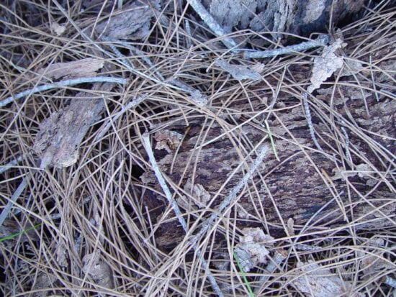

**Tree Recycling Option 3: Brush Reefs**

Christmas trees are used to make habitat for fish, insects, and plants. This habitat is called a **brush reef**. Conservationists in our area want to explore this. But they do not know the type of trees to use, or the best reef shape.

**The Challenge**: Design a prototype of a brush reef that will attract the most living things.

**Constraints**:

* Made from Christmas trees
* Compares at least two design idea
* Sinks to the bottom of a water source
* Uses supplies provided (ask your teacher)

**What has been done before**:

Wreaths can be tied together and sunk using blocks. Sometimes they are tied in a pyramid shape.



Christmas tree limbs are put into buckets with rocks and sunk into water.

