# Turkey Nutrition!

Fill in the blanks during your class discussion about turkey nutrition. Then, keep this worksheet to reference later!

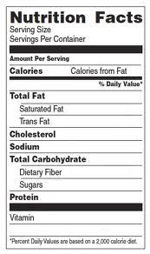

Relatively low calories and fat with high amounts of protein and vitamins

Yes!

B vitamins, selenium, phosphorus

24 grams

2 grams

117

3 ounces

**What food group is turkey in?**

dairy or protein (circle one)

**Can turkey be a part of a healthy diet?**

**What makes turkey healthy or unhealthy?**

**Do you like to eat turkey?**

s:

Other notes to remember:

**My turkey product: My group members:**