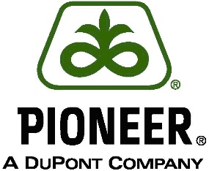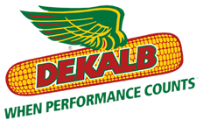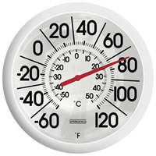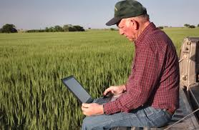**Farmer**

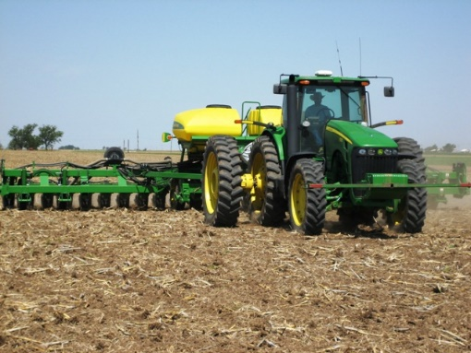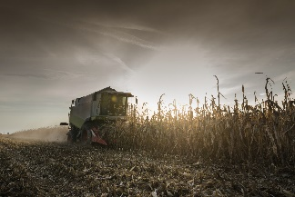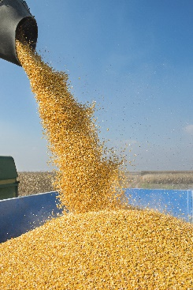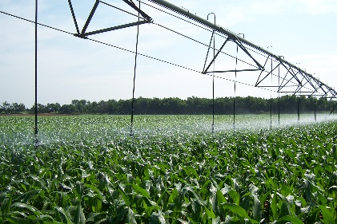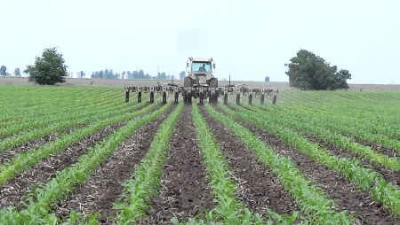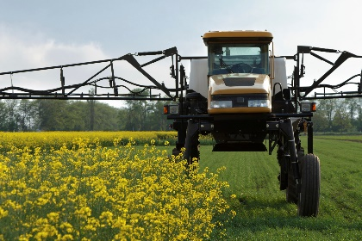The farmer is responsible for planting, caring for, and harvesting the crops. What types of decisions need to be made before planting, and how might they effect the crop?

**Planter**

Corn is planted in the spring, and requires warmth and

moisture to germinate. What factors could affect the

farmer and their crop at this stage?

**Harvest**

Farm equipment is expensive. What are some

benefits and downsides to purchasing equipment like combines,

tractors and planters?

**The Corn**

The corn spends the summer growing under the care of the farmer. What does a farmer have to do to protect his crop as it grows?

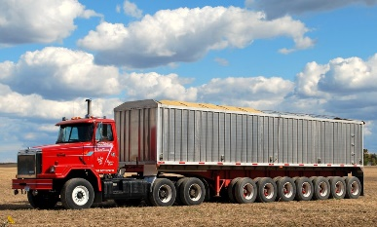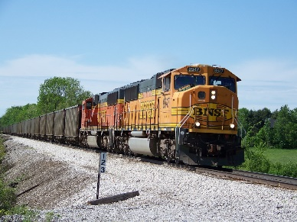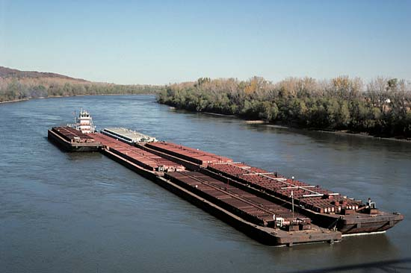

**Transportation**

Corn has to be moved from farm to grain elevator to ethanol plant. What types of transportation can be used? How is fuel used to move the grain?

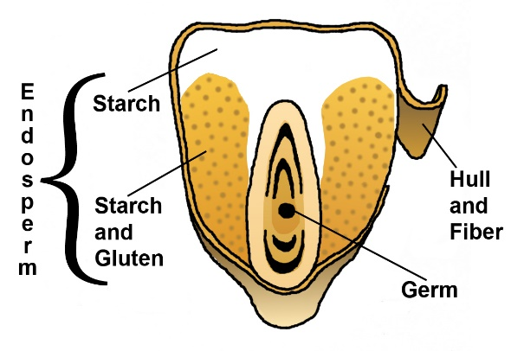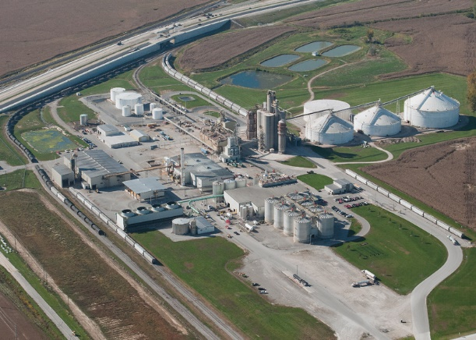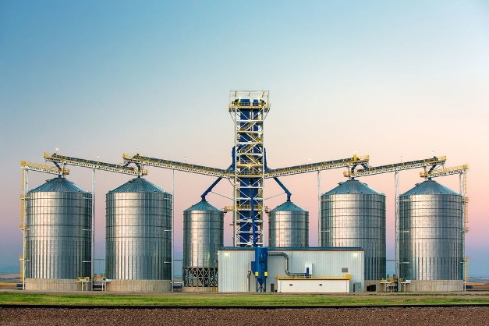

**Ethanol Plant**

This is where corn gets turned into ethanol.

What kind of corn is processed into ethanol?

Why is this type of corn used versus other types?

**Grinder**

Grinding corn exposes the starch from the corn.

Do you think the ethanol process would work if

we didn’t grind the corn? Why or why not?

**Elevator**

What service does a grain elevator provide

for a farmer? Why are these services important?

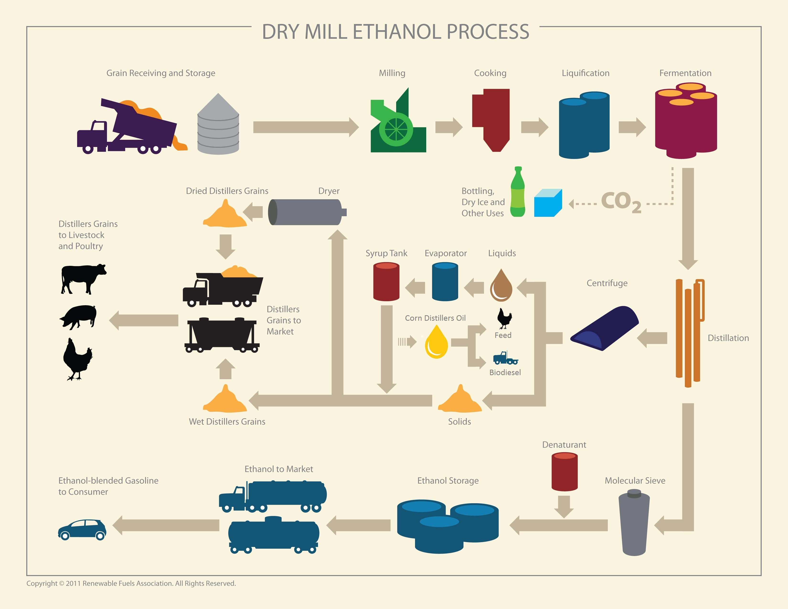

**Cooker**

The ground corn is mixed with water and enzymes and cooked at high

temperatures. The enzymes convert the starch into sugar.

Why is do you think heat used in this process?

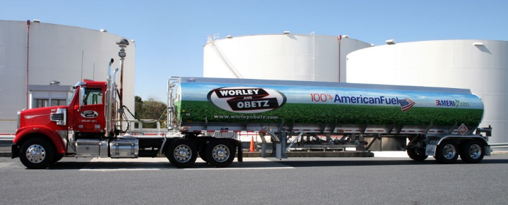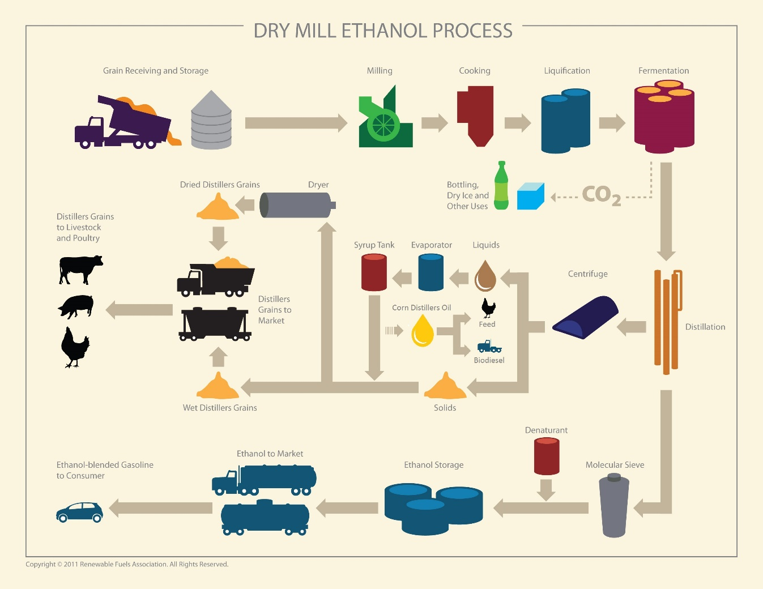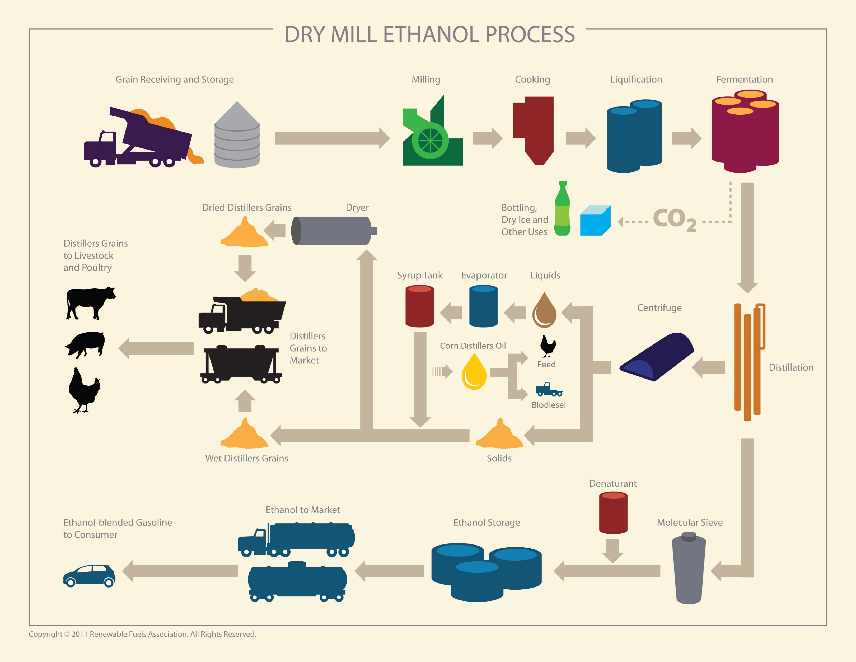

**Delivery**

Ethanol is delivered in special safe delivery trucks.

Why is it important that the ethanol is safely

delivered and stored?

**Molecular Sieve**

The molecular sieve dehydrates the ethanol until it is 100% pure.

Why is it important that the ethanol has no impurities in it?

**Fermentation**

Yeast is added to the cooked mixture of corn. Yeast is the important

ingredient to create fermentation. What are the products of

fermentation?

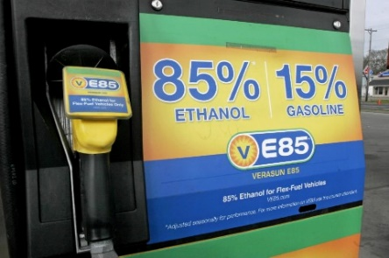

**Retail**

All cars in the U.S. can run on a 15% ethanol/gasoline mix.

However, some cars have special engines designed to run

on an 85% ethanol/gasoline mix, or E85. What advertising tactics are needed to encourage people to use E85 fuel?

*Adapted from “****Tassel to Tank”,*** *Illinois Farm Bureau® Agriculture in the Classroom*