2,500,000 – 10,500 years ago

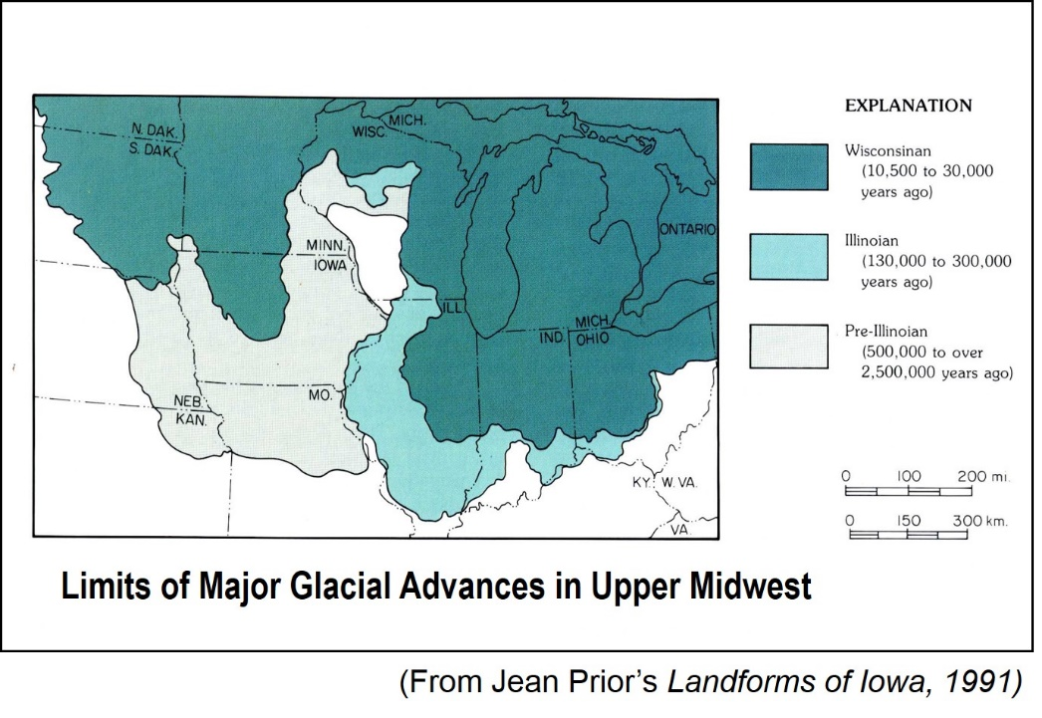

Glaciers moved across Iowa

1000 BC – 1000 AD

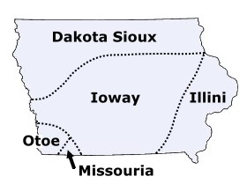

Native American tribes began planting crops

* Iowa had many Native American tribes.
* Some tribes were the Sioux, Ioway, Otoe, Illini, and Missouria.
* Native Americans began keeping seeds from crops and planting them.
* This saved time, so they could build structures, make art, and even trade!
* Glaciers are large, slow-moving sheets of ice and snow
* Glaciers are important because they formed our soil.
* Iowa has some of the best soil in the world!
* We grow crops like corn and soybeans.

1850

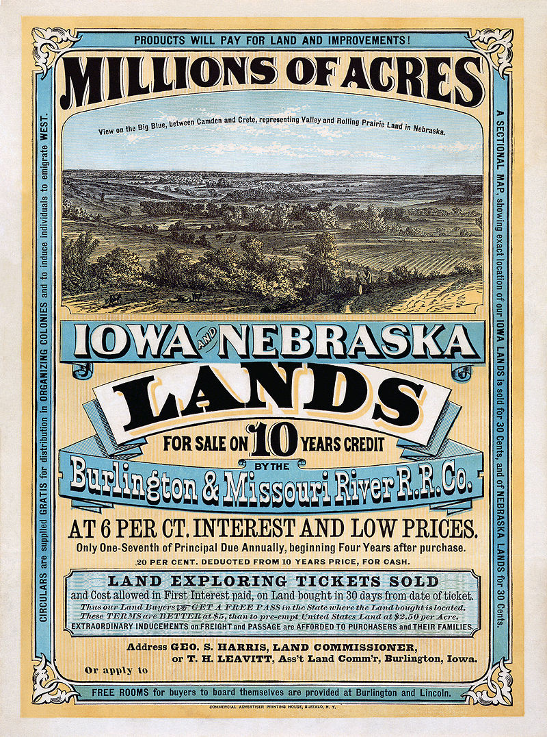

European settlers are moving to Iowa

Civil War Era

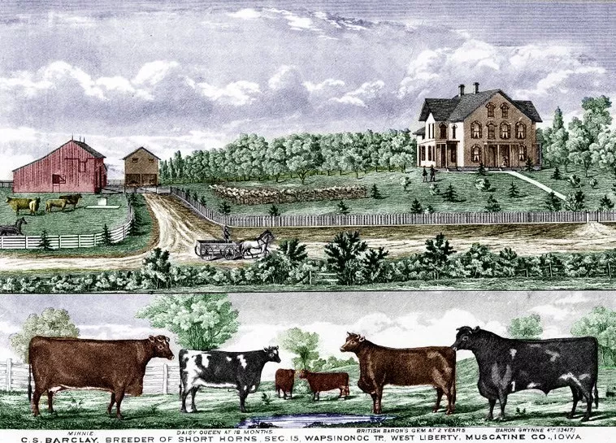

Farmers began planting corn and raising livestock

* Before this, farmers planted more wheat.
* Farmers earned more money for corn!
* Corn also helped feed animals, like cows and pigs.
* Iowa used to be mostly prairies.
* The grass was so tall, children could get lost in it!
* Settlers plowed the land to make farms.
* Almost every family had a farm to feed themselves.

1891

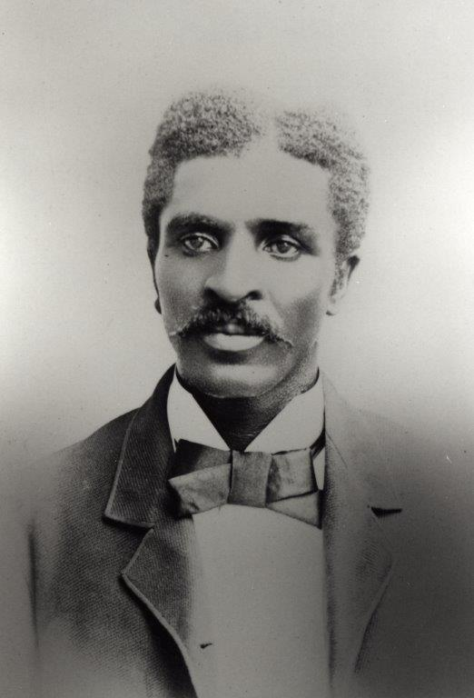

George Washington Carver attends Iowa State Agricultural College

1900

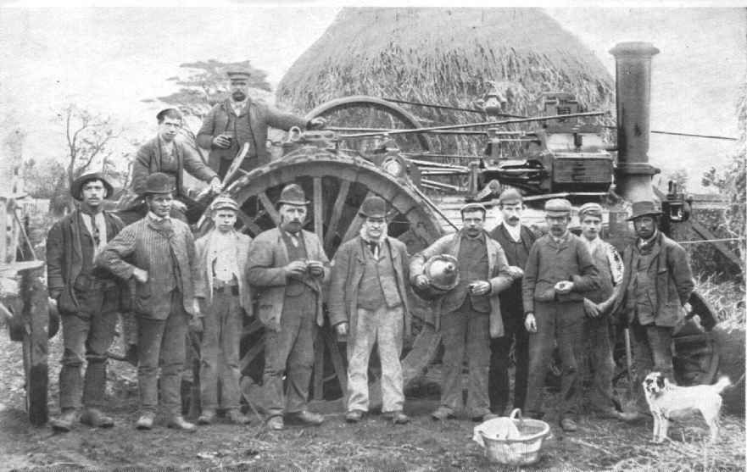

The Golden Age of Agriculture begins

* In the early 1900s, farming became more efficient.
* Farms were run more like businesses.
* Technology on farms grew!
* More people were able to move to towns.
* George Washington Carver studied plants.
* He helped farmers grow plants that help the soil.
* He was the first African American to attend Iowa State.
* He is most famous for studying peanuts!

1926

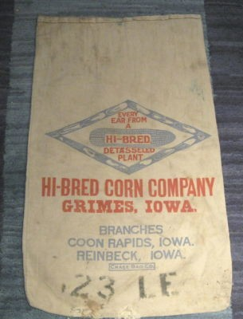

Henry A. Wallace founds the Hi-Bred Corn Company

Today

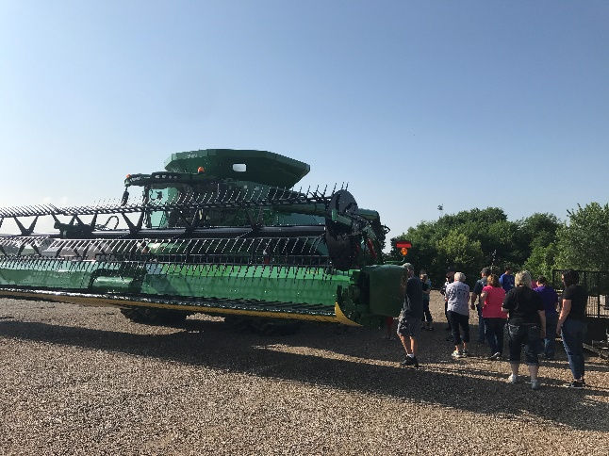

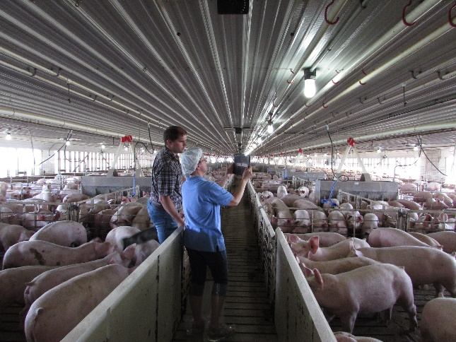

Farms use lots of technology!

* Iowa grows lots of corn, soybeans, pigs, and eggs.
* We also produce lots of ethanol and red meat.
* Modern farms use lots of technology, like GPS.
* About 2% of people live on farms today.
* One farm can feed 166 people! In 1960, one farm fed 26 people.
* Henry A. Wallace was a pioneer in hybrid crops.
* He used new technology to make better corn plants.
* His company grew over time. It is now one of the largest of its kind!
* He became the United States Secretary of Agriculture and Vice President of the United States.