Universal Soil Loss Equation

The Universal Soil Loss Equation, or USLE, estimates soil loss from rill erosion. It estimates the average annual erosion over a 20-year span. The goal is to keep the A value as low as possible, but at least to keep it lower than the soil loss tolerance value, also called the T value. In Iowa, all soil series have a T value of 5 tons/acre/year or less, depending on slope of land and thickness of topsoil.

USLE: **A = RKLS(C1*C2)P**

A = Estimated soil loss (tons/acre/year)

R = rainfall erosion potential

K = soil erodibility

L = Slope length

S = Slope steepness

C1 = crop management factor

C2 = cover crop factor

P = Conservation practices factor

R values

Counties north of the blue line on this map have an R Value of 150. All counties south of this line have an R value of 175.

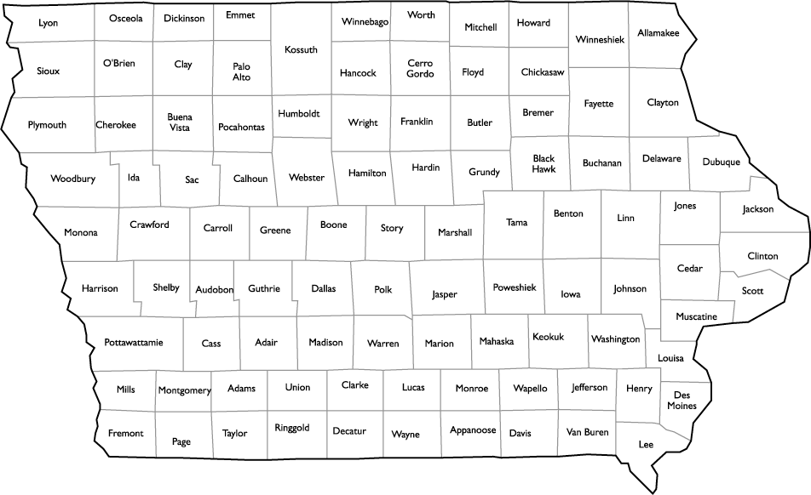

K values of select Iowa soils

0.43 Hamburg, Ida, Weller

0.37 Ames, Clarinda, Clinton, Dubuque, Fayette, Grundy, Haig, Keswick, Onawa, Zook

0.32 Adair, Dinsdale, Downs, Galva, Hayden, Ladoga, Marshall, Monona, Otley, Sharpsburg

0.28 Clarion, Clyde, Colo, Gara, Judson, Kenyon, Luton, Macksburg, Mahaska, Marcus, Muscatine, Primghar, Shelby, Sogn, Stordon, Taintor, Tama, Winterset

0.24 Floyd, Nicollet, Webster

0.22 Dickenson

0.17 Sparta

L x S values

In this equation, L and S are combined for a single value. Use this table to find the value using the length and slope of the soil in question.

|  |  |  |  |  |  |  |  |  |  |  |
| --- | --- | --- | --- | --- | --- | --- | --- | --- | --- | --- |
| **Slope** | **Percent Slope** | | | | | | | | | |
| **Length** | **2%** | **4%** | **6%** | **8%** | **10%** | **12%** | **14%** | **16%** | **18%** | **20%** |
| **50’** | 0.1 | 0.3 | 0.5 | 0.7 | 0.9 | 1.2 | 1.6 | 2.0 | 2.5 | 3.0 |
| **100’** | 0.2 | 0.4 | 0.7 | 1.0 | 1.4 | 1.8 | 2.3 | 2.9 | 3.5 | 4.2 |
| **150’** | 0.3 | 0.5 | .08 | 1.2 | 1.7 | 2.2 | 2.8 | 3.5 | 4.3 | 5.1 |
| **200’** | 0.3 | 0.6 | 1.0 | 1.4 | 2.0 | 2.6 | 3.3 | 4.1 | 4.9 | 5.9 |
| **250’** | 0.3 | 0.7 | 1.1 | 1.6 | 2.2 | 2.9 | 3.7 | 4.6 | 5.5 |  |
| **300’** | 0.4 | 0.7 | 1.2 | 1.7 | 2.4 | 3.2 | 4.0 | 5.0 |  |  |
| **350’** | 0.4 | 0.8 | 1.2 | 1.9 | 2.6 | 3.4 | 4.3 | 5.4 |  |  |
| **400’** | 0.5 | 0.8 | 1.3 | 2.0 | 2.7 | 3.6 | 4.8 | 5.8 |  |  |

C1 values

This value looks at both tillage type and crop rotation, or what crops are planted in the same field year after year. In the rotations, R means a row crop, like corn or soybeans. O means oats or wheat. M means meadow, or grasses or legumes, like alfalfa. Use the table below to find your C value.

|  |  |  |  |  |  |
| --- | --- | --- | --- | --- | --- |
| **Management** | **Rotation** | | | | |
| **RR** | **RRROM** | **RROM** | **ROM** | **ROMM** |
| **Fall moldboard** | 0.33 | 0.18 | 0.14 | 0.09 | 0.07 |
| **Spring moldboard** | 0.29 | 0.15 | 0.12 | 0.07 | 0.06 |
| **Chisel plow – 20% cover after planting** | 0.21 | 0.12 | 0.10 | 0.07 | 0.06 |
| **Chisel plow – 40% cover after planting** | 0.15 | 0.08 | 0.07 | 0.05 | 0.04 |
| **No till – 50% cover after planting** | 0.06 | 0.04 | 0.04 | 0.03 | 0.02 |
| **No till – 70% cover planting** | 0.04 | 0.03 | 0.03 | 0.02 | 0.02 |

C2 values

To determine the impact of the cover crop you chose, multiply the corresponding value with the C1 value before plugging it into the full equation.

0.77 Cereal rye

0.75 Winter wheat

0.78 Triticale

0.83 Turnips

0.85 Radishes

P values

If none of these values are met, use 1.0.

|  |  |  |  |  |  |
| --- | --- | --- | --- | --- | --- |
| **Slope** | **Contour planting** | **Strip cropping** | | **Terraces** | |
| **RROM** | **ROMM** | **Grassed waterways** | **Underground outlets** |
| **1-2%** | 0.60 | 0.45 | 0.30 | 0.12 | 0.05 |
| **3-5%** | 0.50 | 0.37 | 0.25 | 0.10 | 0.05 |
| **6-8%** | 0.50 | 0.37 | 0.25 | 0.10 | 0.05 |
| **9-12%** | 0.60 | 0.45 | 0.30 | 0.12 | 0.05 |
| **13-16%** | 0.70 | 0.52 | 0.35 | 0.14 | 0.05 |
| **17-20%** | 0.80 | 0.64 | 0.40 | 0.16 | 0.06 |
| **21-25%** | 0.90 | 0.67 | 0.45 | .018 | 0.06 |

Calculations:

1. Using the information from your farmer’s profile, including the cover crop you chose to implement, calculate USLE.
2. Did the USLE fall at or below the recommended 5? If yes, what factors helped keep the value low? If no, what factors worked against them?
3. How would the value change if tillage was changed to fall moldboard? Is this a higher or lower value than previously?
4. How would the original value change if the crop rotation was changed to ROMM?
5. How do the different cover crops affect the equation differently?