**Create Your Own Herd!**

Names_______________________________________Date________________Period________

Today, you and your partner will create your own cattle herd! You will monitor ten real traits, discover your parents’ genotypes, and then find the offspring’s genotypes. When you discover all that, you will draw them!

**Traits of Interest**

Here are the ten traits you will be working with. Generally, the dominant allele will be a capital letter, and the recessive allele will be the same letter in lower-case.

|  |  |  |
| --- | --- | --- |
| **Trait** | **Dominant allele** | **Recessive allele** |
| Polled vs. Horned | Polled: P | Horned: p |
| Black vs. Red hide | Black: B | Red: b |
| Solid vs. Spotted coat | Solid: S | Spotted: s |
| White face vs. Colored face | White face: F | Black: f |
| Solid legs vs. Stocking legs | Solid: L | Stocking: l |
| Large Rib Eye Area vs. Small Rib Eye Area | Large: R | Small: r |
| High birthweight vs. Low birthweight | High: H | Low: h |
| Heat tolerant vs. Heat susceptible | Tolerant: T | Susceptible: t |
| Docile vs. Rowdy | Docile: D | Rowdy: d |
| Male (XY) vs. Female (XX) | Male: XY | Female: XX |

**Dam and Sire**

Now it’s time to discover the mother (dam) and father’s (sire) genotypes. Flip the coin twice for each trait to decide the alleles given to each parent. Heads will give a dominant allele and tails will give a recessive allele. List the phenotype as well as the genotype.

|  |  |  |  |  |
| --- | --- | --- | --- | --- |
| **Trait** | **Father Genotype** | **Father Phenotype** | **Mother Genotype** | **Mother Phenotype** |
| Polled vs. Horned |  |  |  |  |
| Black vs. Red hide |  |  |  |  |
| Solid vs. Spotted coat |  |  |  |  |
| White face vs. Colored face |  |  |  |  |
| Solid legs vs. Stocking legs |  |  |  |  |
| Large Rib Eye Area vs. Small Rib Eye Area |  |  |  |  |
| High birthweight vs. Low birthweight |  |  |  |  |
| Heat tolerant vs. Heat susceptible |  |  |  |  |
| Docile vs. Rowdy |  |  |  |  |
| Male (XY) vs. Female (XX) | **XY** | **Male** | **XX** | **Female** |

**Draw the Parents**

Once you have the genotypes for all ten traits for the mother and father, you will then need to draw them on your poster. Make them look as best and accurate as you can. For traits that are not visual, labels are acceptable.

**Punnett Squares**

Now you will have to make Punnett Squares for all ten traits based on the parents’ genotypes. Make sure to give the odds for genotype and phenotype along with probability for each. Write the sire’s genotype at the top of the Punnett Square, and the dam’s genotype on the left side of the Punnett Square. **Example:**

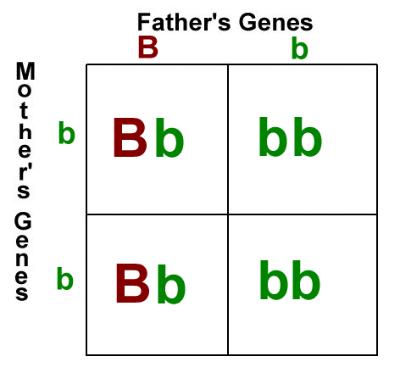

Polled vs. Horned- Black vs. Red- Solid vs. Spotted-

|  |  |  |  |  |  |  |  |
| --- | --- | --- | --- | --- | --- | --- | --- |
|  |  |  |  |  |  |  |  |
|  |  |  |  |  |  |  |  |

Genotype Ratio: Genotype Ratio: Genotype Ratio:

Phenotype Ratio: Phenotype Ratio: Phenotype Ratio:

Probability: Probability: Probability:

White vs. Colored Face- Solid vs. Stockings- Large vs. Small REA-

|  |  |  |  |  |  |  |  |
| --- | --- | --- | --- | --- | --- | --- | --- |
|  |  |  |  |  |  |  |  |
|  |  |  |  |  |  |  |  |

Genotype Ratio: Genotype Ratio: Genotype Ratio:

Phenotype Ratio: Phenotype Ratio: Phenotype Ratio:

Probability: Probability: Probability:

High vs. Low Birthweight- Heat Tolerant vs. susceptible- Docile vs. Rowdy-

|  |  |  |  |  |  |  |  |
| --- | --- | --- | --- | --- | --- | --- | --- |
|  |  |  |  |  |  |  |  |
|  |  |  |  |  |  |  |  |

Genotype Ratio: Genotype Ratio: Genotype Ratio:

Phenotype Ratio: Phenotype Ratio: Phenotype Ratio:

Probability: Probability: Probability:

Male vs. Female-

|  |  |  |  |  |  |  |  |
| --- | --- | --- | --- | --- | --- | --- | --- |
|  |  |  |  |  |  |  |  |
|  |  |  |  |  |  |  |  |

Genotype Ratio:

Phenotype Ratio:

Probability:

**The Calf**

Now, you need to discover the calf’s traits. An allele from each parent needs to be passed on to the calf. Choose the most probable genotype from your Punnett Square for each trait. If two genotypes are equally probable, flip a coin to decide between the two.

|  |  |  |
| --- | --- | --- |
| **Trait** | **Genotype** | **Phenotype** |
| Polled vs. Horned |  |  |
| Black vs. Red hide |  |  |
| Solid vs. Spotted coat |  |  |
| White face vs. Colored face |  |  |
| Solid legs vs. Stocking legs |  |  |
| Large Rib Eye Area vs. Small Rib Eye Area |  |  |
| High birthweight vs. Low birthweight |  |  |
| Heat tolerant vs. Heat susceptible |  |  |
| Docile vs. Rowdy |  |  |
| Male (XY) vs. Female (XX) |  |  |

**Draw the Baby**

Now, draw the baby on the bottom half of your poster. Again, be as accurate as possible, and use color. Put your names on your poster.

**Think it Through…**

If you were a cattle farmer, would you want the traits your calf had in your herd? Why or why not? If you knew the traits of the parents before you bred them, would you still have chosen them to be parents? How might environment impact which traits you want? What other traits do you think cattle farmers monitor in their herd?