# Turkey Nutrition!

Fill in the blanks during your class discussion about turkey nutrition. Then, keep this worksheet to reference later!

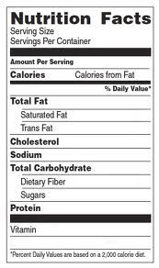

**What food group is turkey in?**

dairy or protein (circle one)

**Can turkey be a part of a healthy diet?**

**What makes turkey healthy or unhealthy?**

**Do you like to eat turkey?**

s:

Other notes to remember:

**My turkey product: My group members:**