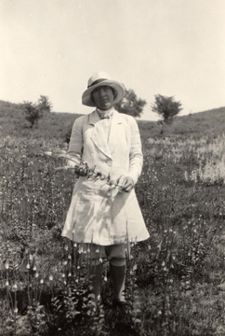**Ada Hayden –** Ada Hayden was born in 1884 in Ames, Iowa. She was raised in Ames and while she was growing up, she became interested in prairie land. She wanted to work to help protect the prairie land because at the time there were not any state programs that preserved prairie land. She earned a Bachelor of Science degree from Iowa State University then went on to earn her Ph.D. in philosophy. In her career she traveled around the state, visiting different prairies that remained in the state. Ada Hayden spent her career as an assistant professor of botany from 1919 to 1950. During her career, she added more than 40,000 specimens to the herbarium. After Ada died in 1950, the state bought 22 prairies and named one after her, the Ada Hayden State Preserve in Howard County, Iowa.

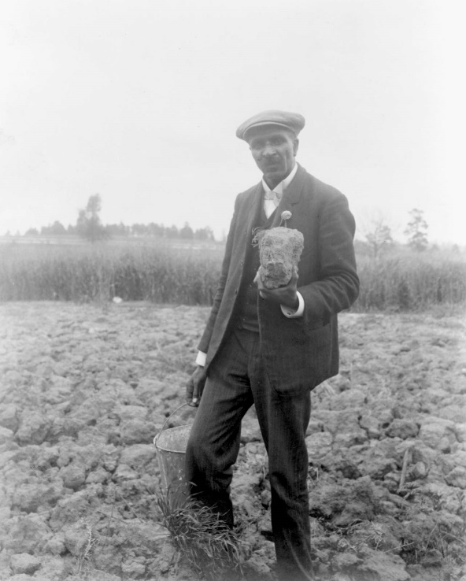**George Washington Carver** –George Washington Carver was a scientist and educator. He was born in 1865 in Missouri, and he attended Iowa State University to study botany. He was the first African American student at Iowa State University. He earned his bachelor’s degree in science and continued his education at Iowa State University. Eventually he earned his master’s degree. He began his professional career as a professor at Iowa State University. Then he was contacted by Booker T. Washington to teach at a college in Tuskegee, Alabama. George accepted and taught at Tuskegee Institute. George Washington Carver is best known for his work with crop rotation and peanuts. He found that rotating crops in the south like cotton with crops like sweet potatoes and soybeans replenished the soil. George also found that peanuts helped reduce another problem that farmers were facing like the boll weevil. He introduced hundreds of new peanut products, including cooking oils, dyes for clothing, plastics, fuel for cars, and peanut butter.

**Henry A. Wallace-** Henry Wallace, born in 1888 on a farm in Adair County, Iowa, was instrumental to agriculture. He was an editor, geneticist, cabinet officer, and 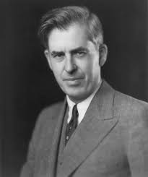Vice President of the United States. He attended Iowa State College and studied agriculture. After graduation, he worked as a reporter and editor at *Wallaces’ Farmer*. Henry Wallace also had an interest in corn breeding. He began experiments where he crossed two lines of hybrid corn. He and his wife started a business, Pioneer Hi-Bred, the world’s first company to develop, grow, and sell hybrid seed.

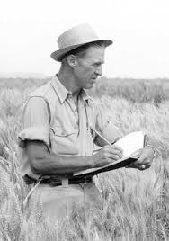**Norman Borlaug-** Norman Borlaug, known as the Father of the Green Revolution, was born in 1914 in Cresco, Iowa. He studied forestry at the University of Minnesota and went on to earn his Master of Science degree and a Ph.D. in plant pathology and genetics. He worked as a microbiologist at DuPont. Soon he learned the Mexican government was interested in establishing a Cooperative Wheat Research and Production Program. He spent his first ten years in Mexico developing disease-resistant strains of wheat. Then he introduced dwarfing in his hybrids to produce a thicker, shorter stem to support the wheat from collapsing under the weight of its grain. When Mexican farmers used Borlaug’s wheat varieties it resulted in a 6x yield increase. The seeds were also sent to India and Pakistan, where farmers were able to become self-sufficient in wheat production. Norman began teaching at Texas A&M University, where he also conducted research. He received top honors during his career, including the Nobel Peace Prize in 1970 and the U.S. Presidential Medal of Freedom in 1977.

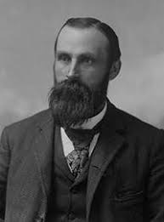**John Froelich –** John Froelich was the inventor of the first internal-combustion motor. He was born in Girard, Iowa. He went to school in Galena, Illinois, and at the College of Iowa. During his career, he operated a grain elevator and threshing service. He and his crew used steam-powered threshers throughout Iowa and the Dakotas. This machine was heavy, hard to transport, and very dangerous. One spark from the broiler could cause the whole field to set fire. He became inventive and mounted a one-cylinder gasoline engine on his tractor and tested it out! It worked! The new engine only used 26 gallons of gas and could thresh more than one thousand bushels of grain every day without having to worry about setting fire to the field. In 1894, Froelich and eight investors formed the Waterloo Gasoline Traction Engine Company. In 1918, the John Deere plow-manufacturing company bought John’s business for $2.35 million.

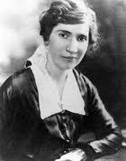**Jessie Field Shambaugh –** Jessie Field Shambaugh is an educator and the founder of 4-H. She was born near Shenandoah, Iowa in 1917, and graduated from Tabor College. She was a teacher in Page County and organized the boys’ and girls’ clubs that became the model for 4-H. The boys studied farm management, agronomy, livestock and corn judging. The girls learned about cooking, sewing, interior decoration, gardening, first aid, and childcare. She is best remembered for her work in establishing clubs that grew into one of the greatest youth movements in the 20th century. She also created a significant model for how to teach at rural schools.